***QUESTIONS & ANSWERS***

1. **What is Python and Why is it popular?**

Python is a high-level, interpreted programming language known for its simplicity, readability, and versatility. Python's syntax is easy to read and write, making it an excellent choice for beginners & Experts too. It is also an open source language, which means it is free to use and modify.

It is used for web development (server-side), Software development, AI, Scientific computing, ML and more.

Python is popular for the below reasons:

* Open Source
* Easy to Learn and Use
* Versatile
* High Demand

1. **What are the differences between Python 2 and Python 3?**

|  |  |  |
| --- | --- | --- |
| **Key** | **Python 2** | **Python 3** |
| **Release Date** | 2000 | 2008 |
| **Syntax** | More Complex and difficult to interpret | Readable and easily understandable |
| **Performance** | Slower performance due to design flaws | Improved performance of the code’s runtime compared to Python |
| **Print Function** | Print “Hello Raji” | Print(“Hello Raji”) |
| **Integer Divison** | Results and integer value | Results in float |
| **Range** | xrange() function is used to create a sequence of numbers | range() is more efficient than xrange() |
| **Backward Compatibility** | Easily port Python 2 to Python 3 | Python 3 is not backwardly compatible Python 2 |
| **Libraries** | Many older libraries are not forward compatible to Python 3 | Most of the new libraries are not backward compatible to Python 2 |

1. **What is the difference between a tuple and a list in Python?**

|  |  |  |  |
| --- | --- | --- | --- |
| **S.No** | **Key** | **List** | **Tuple** |
| **1** | Type | List is Ordered & Changeable. | Tuple is Ordered & Unchangeable. |
| **2** | Iteration | List iteration is slower and is time consuming. | Tuple iteration is faster. |
| **3** | Advantage | List is useful for insertion and deletion operations. | Tuple is useful for read only operations like accessing elements. |
| **4** | Memory Consumption | List consumes more memory. | Tuples consumes less memory. |
| **5** | Methods | List provides many in-built methods. | Tuples have less in-built methods. |
| **6** | Performance | Creating a list is slower because two memory blocks need to be accessed. | Creating a Tuple is more faster than a List. |

1. **How do you create a dictionary in Python?**

Dictionaries are used to store data values in key:value pairs. A dictionary is a collection which is ordered, changeable and do not allow duplicates.

**Example:**

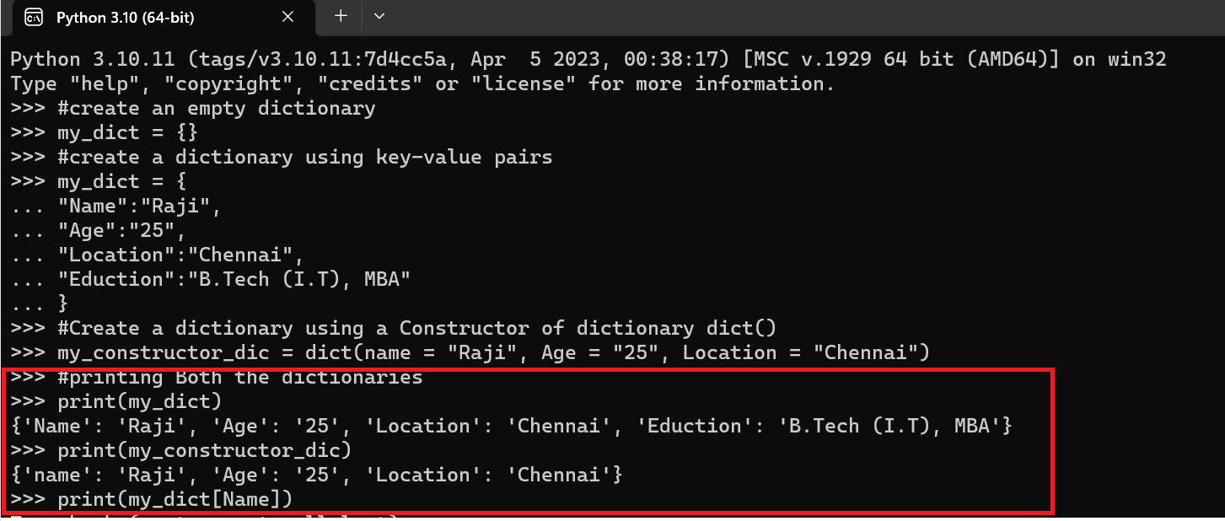

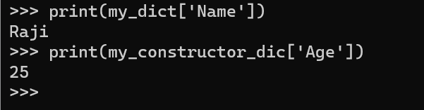

We can access keys with keys() and all the values with values().

1. **What is a function in Python and how do you define one?**

Functions are blocks of reusable code that perform a single task. You can pass data, known as parameters, into a function. A function can return data as a result.

We can define using the keyword **“def”** followed by a name of the function and the colon.

**Example:**

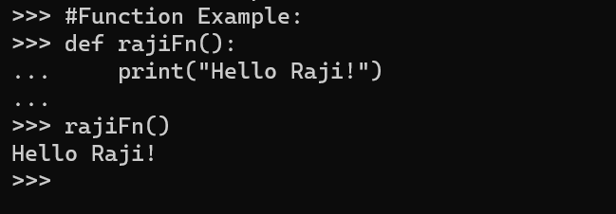

1. **What is object-oriented programming (OOP) and how does it relate to Python?**

OOPs is a concept of modern programming language that allows programmers to organize entities and objects. It allows the users to create objects based on the requirement and then create methods to operate upon those objects.

The key principles of OOPs:

1. Abstraction
2. Encapsulation
3. Inheritance
4. Polymorphism

**Python is a programming language that supports OOP.** In Python, everything is an object, and you can define your own classes to create objects with custom properties and behavior. Python also supports inheritance and polymorphism, making it a powerful language for OOP programming.

1. **How do you handle exceptions in Python?**

 An exception is an event, which occurs during the execution of a program that disrupts the normal flow of the program's instructions.

Types: Built-in Exception and User-Defined Exception

We can handle exceptions using the ‘try’ and ‘except’ block.

**Example:**

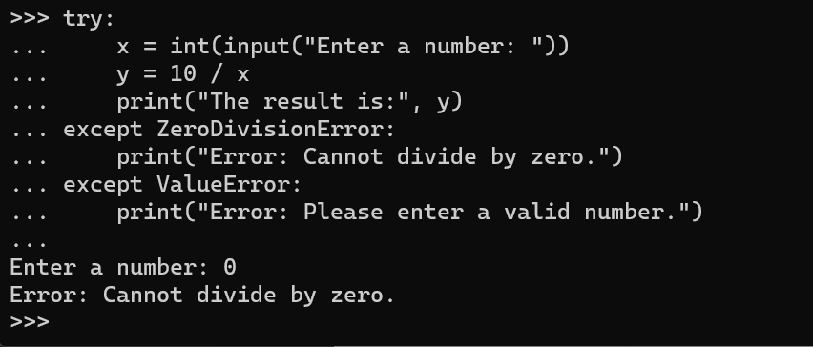

However, if the user enters a value of 0, a ZeroDivisionError will be raised, and the code inside the except ZeroDivisionError block will be executed. If the user enters a value that cannot be converted to an integer, a ValueError will be raised, and the code inside the except ValueError block will be executed.

We can also use the else keyword to specify a block of code that should be executed if no exceptions are raised.

And also we use the finally keyword to specify a block of code that should be executed regardless of whether an exception is raised.

Another simple example:

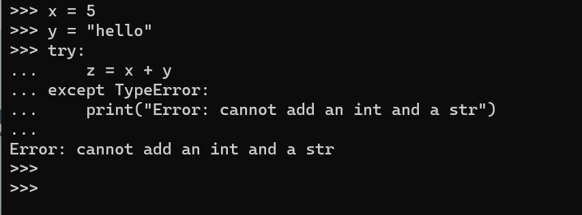

1. **How do you read and write files in Python?**

File handling is an important part of any web application. Python has several functions for creating, reading, updating, and deleting files.

To read and write files in Python, you can use the built-in open() function. This function returns a file object, which can be used to read from or write to a file.

**Example**

Reading a content from file:

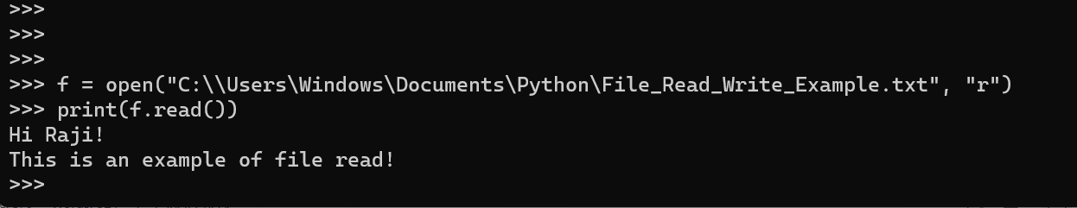

**Writing a content from file:**

Create a file called "mydocu.txt" and then write a content and reading from that file:

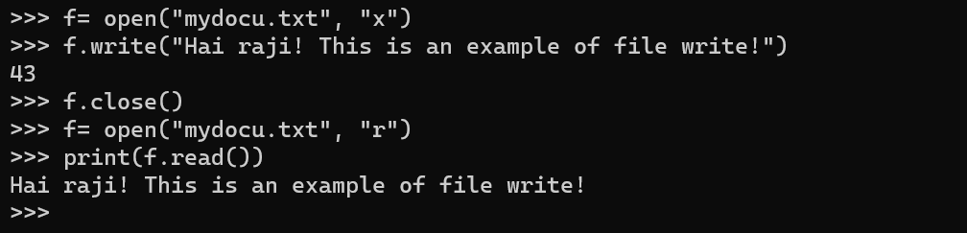

1. **How do you install and use external packages in Python?**

To install external packages in Python, you can use a package manager like pip.

Pip is the default package manager for Python and comes pre-installed with most Python distributions. Here's how to use pip to install a package:

Open a command prompt or terminal window.

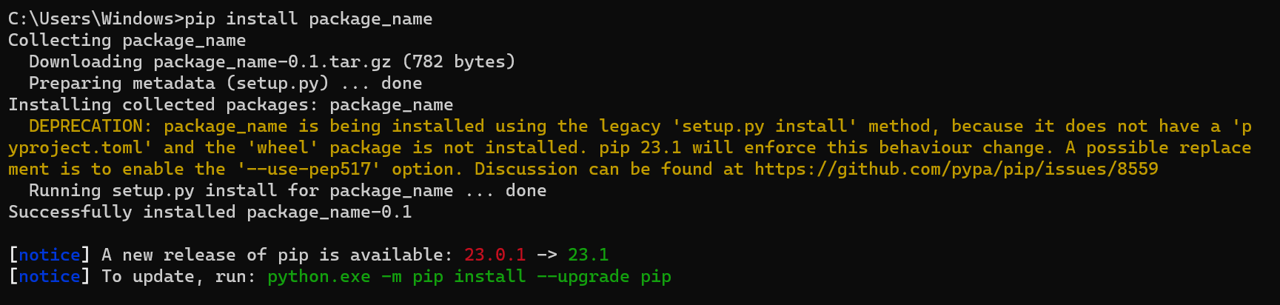

Replace package_name with the name of the package you want to install. Wait for the installation to complete. Pip will download the package and install it along with any dependencies.

To use the package in your Python code, you need to import it. Here's how to import a package:

**import package_name**

This will import the entire package and make all its functions and classes available to your code. You can then use them as you would use any other Python object.

If you only need to use a specific function or class from the package, you can import it directly:

**from package_name import function_name**

This will import only the specified function or class and make it available to your code.Note that some packages may require additional configuration or setup before they can be used.

1. **How do you use the "if" statement in Python to perform conditional execution?**

The IF statement is used to perform the conditional execution of code.

It will check if a condition is true. Essentially, if the condition is true, the Python interpreter runs a block of statements called the if-block.

If the statement is false, the interpreter skips the if block and processes another block of statements called the else-block. The else clause is optional.

**Example:**

